In this video we are going to download and install Unity
So for this first go to link
https://unity.com/download
Or you can go to google and then search download Unity
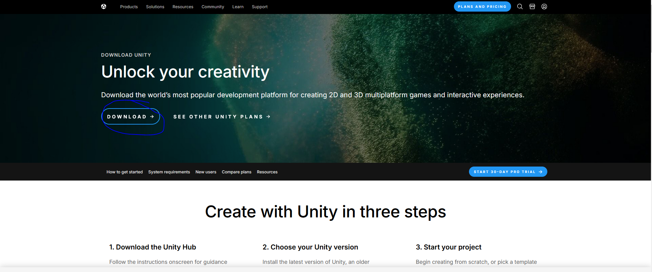
From here you need to create an account of yours
If you don't have an account you need that account to download and also for getting your license
Now click on Download button to download according to your operating system and then you need to install Unity hub
Once you install it unity hub will be installed simply go ahead and launch it.
Now Unity hub looks like this
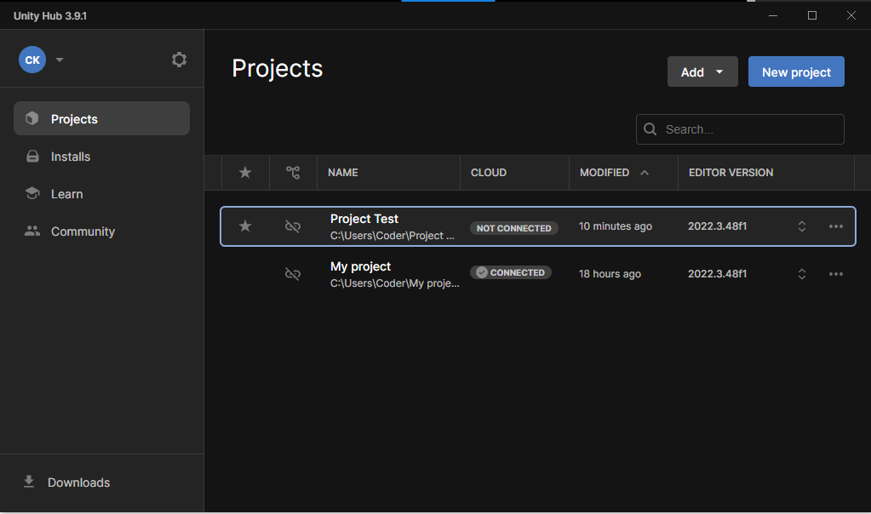
Now go to Installs tab and here you have all the editor installed in your PC. Like below
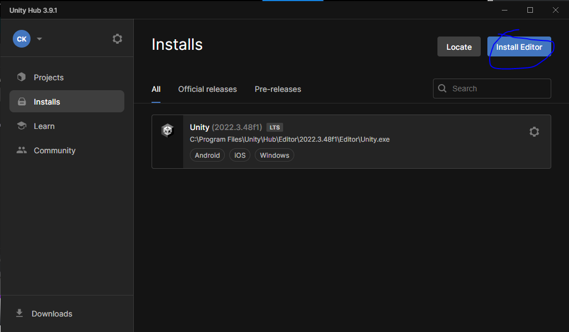
Go to install editor as marked above
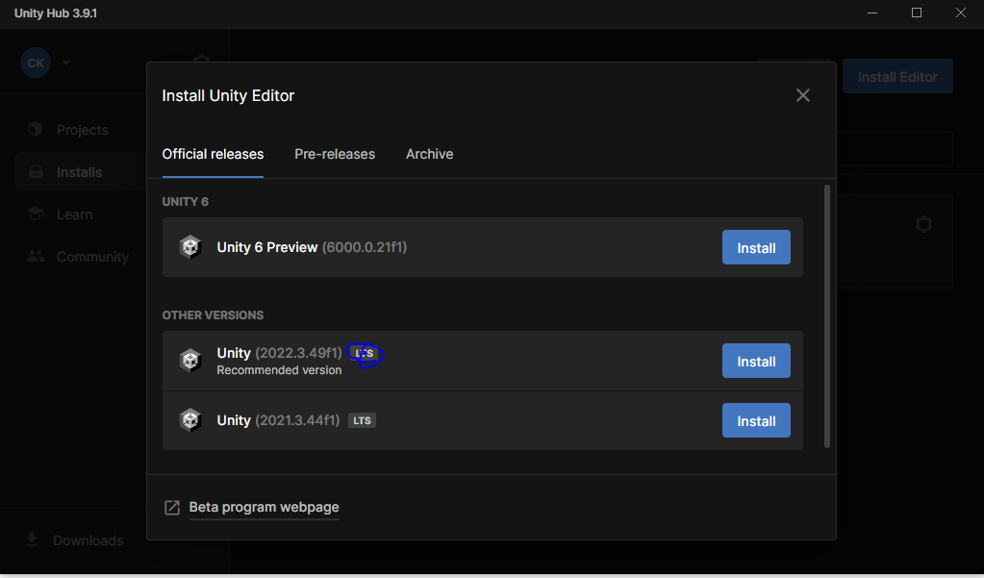
And here you see all the editor installed
Here above you can see the LTS or long term support as marked above
If you are building a long project then you need to use some version that will be supported by unity for long
Otherwise you need to install the latest version of unity
Or you can go to Pre release tab and from here install latest beta version.
Now if you want to install any of them then click on the install button assosiated with it.
After clicking on it the screen looks like this
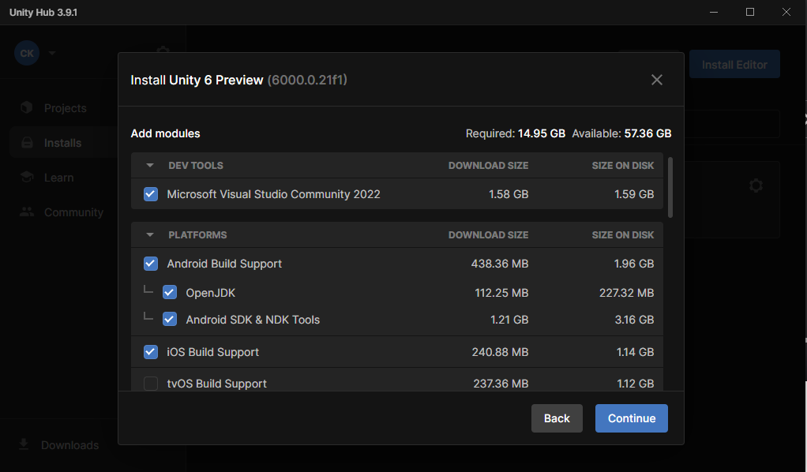
Here you need to install the component that are required for your game
Visual Studio is required for coding our games
Make sure it is checked
For making games for android we need to check android Build Support and make sure that Open JDK and Android SDK and NDK Tools
To make games for IOS check the IOS build support
If you want to build for WebGL
then check the WebGL Build Support
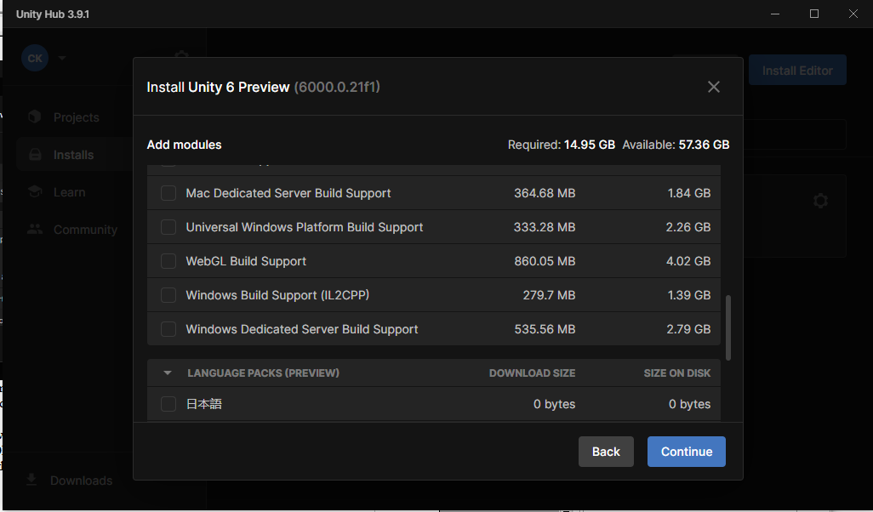
Once you have done that click on continue to move forward. And then these things will be installed in your Editor. Also another thing you need to learn is that go to Setting as marked below
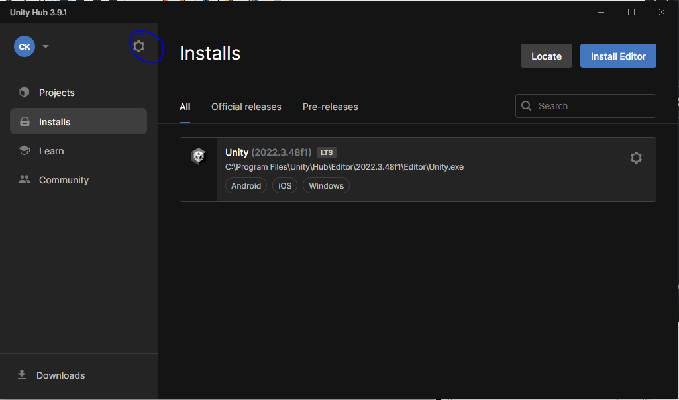
and then in new mini window inside it
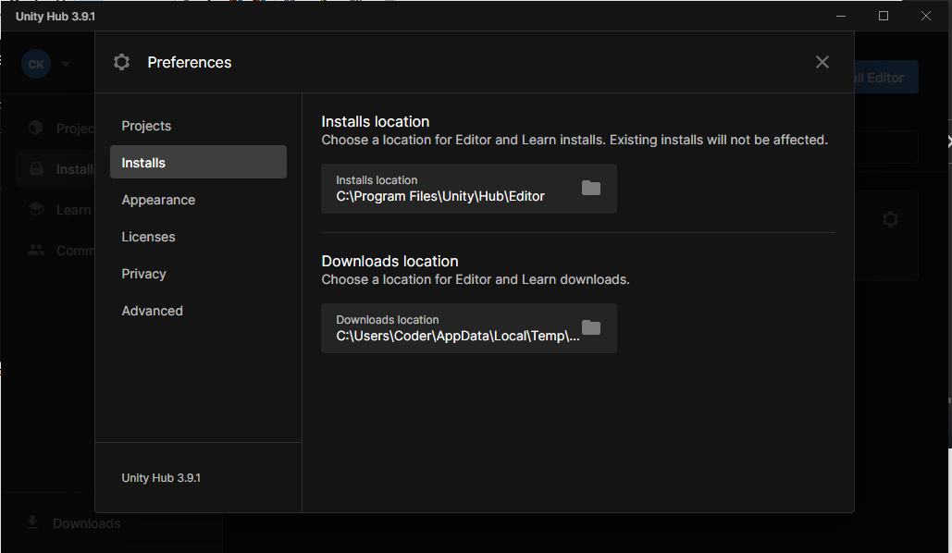
Now go to Installs side tab and then in Installs location field you can set the location where you can put your saved installed things
Now you are finally ready to start building games.

